Author’s response

To introduce the German context of CCS, which is fundamental to understand the media coverage of CCS in Germany, I have added a brief and attentive publication review of other studies about CCS in Germany to the article. This will help to understand the German CCS context in more detail. In addition, table 1 is added to the article to provide further details on the timeline and history of CCS research, CCS policy and the decision making process of the German CCS law.

Unfortunately, the article invited to misinterpret the way scientific integrity might be related to CCS. Within the revised version of the article, I tried to re-formulate this issue, so that scientific integrity now is related to responsible and thorough scientific process regardless of the attitude and outcome (pro or con) towards CCS.

The decision by BGR not to publish the map (this has actually been a more detailed register) of potential CCS storage sites cannot be evaluated from my perspective, since I have no insights into BGR decision making routines of that time. The reviewers commented, that those decision routines and the BGR’s internal context would help to understand why the register was not published. Nevertheless, in regard to the analysis of media coverage of CCS, the BGR’s internal motives in this respect are of no greater importance because this study focused amongst other issues on selection routines of journalists and which actors were chosen as competent voices within the CCS theme.

The reviewers remarks on the use of the concept of "emotions" are well taken. While there are numerous concepts and theories about the role of emotions in communication, this study looks at emotions in quite a simplistic way. Nevertheless, I used the concept of emotions used by other social and communication scholars (e.g. Ungerer, 1997 or Wierzbicka,1995), too. Therefore, I have added some cross-references to studies, from which I have adopted the conceptualization of emotion.

The reviewers comment on the selection of articles by using the keyword coal are put into the German context. This will explain the validity of the used routine. To further illustrate the sampling process, I have added a schematic figure (figure 2) about the sampling routine. These additions will help to understand the analysis design and the methods used.

Further corrections within the graphics used as well as grammatical revisions were made.

All changes can be see within the following document.

Simon Schneider
Potsdam, 13 September 2018

The Takeover of Science Communication: How Science Lost Its Leading Role in the Public Discourse on Carbon Capture and Storage Research in Daily Newspapers in Germany
Simon Schneider¹
¹Department for Earth and Environmental Sciences, University of Potsdam, Potsdam, 14476, Germany
Correspondence to: Simon Schneider (simschne@uni-potsdam.de)
Abstract. CCS (Carbon Capture and Storage) is an important issue within the context of climate-change mitigation options; it has played a major role in the agendas of scientists, researchers, and engineers. While media representations of CCS in Germany from 2004 to 2014 demonstrated the significant medialization of the topic, this cannot be ascribed to science. Instead, CCS media coverage in Germany was dominated by other stakeholder groups. While CCS is linked to various industry sectors, such as cement and steel production, the German debate predominantly focused on the coal and energy branches. This study looks at the role of science and science PR within the German public debate by analysing the media coverage of CCS in daily newspapers from 2004 to 2014. If science is to remain proactive within science communication, new approaches for future science public relations (PR) have to be deduced to strengthen, once again, the role of science communication. Among these approaches, it is important to pursue a more differentiated understanding of target audiences and regional concerns. Science PR has to accept that science itself is no longer the only stakeholder and actor within science communication.

1 Introduction
Scholars of communication science have debated the interdependencies between the media and public-relation offices (Altmeppen, 2004; Raupp & Vogelgesang, 2009). It has been openly discussed whether journalists have turned into Public Relations (PR) professionals or whether press offices at universities and research institutions have already taken issue management (Chase, 1977), agenda-building (Cobb & Elder, 1997), and even journalistic tasks into their own hands (Schnedler, 2011).
Particularly in the case of science journalism, which over the last decade has undergone fundamental changes due to budget and personnel cuts that have led to the closure of many science departments on newspapers (Brumfiel, 2009; Rögener & Wormer, 2017), it can be observed that effective – and despite all doubts sometimes qualitatively valuable – public relations carried out by universities and research institutions has already spearheaded the media coverage of special areas of science (Rögener & Wormer, 2017; Berg, 2018). Studies on the complex interrelation of PR and journalism (Macnamara, 2014; Williams & Gajevic, 2013; Nelkin, 1995) have shown that PR-dominated science journalism is in fact a reality: “many journalists are in effect retailing science and technology more than investigating it, identifying with their sources more than challenging them” (Nelkin, 1995, p. 164). The level of influence is inconsistent; Reich, for example, has observed that “studies have attempted to establish a bottom line for PR-originated input, ranging between 25 to 80 percent of news content” (Reich, 2010, p. 799). This might be related to system-specific differences within the national media landscape, as well as the diversity of scientific approaches in the relevant studies (Reich, 2010). Within this context, this study will focus on CCS (Carbon Capture and Storage) technology.
The analysis of CCS media coverage in German print daily newspapers provides valuable insights and, because of its complex nature, requires scientific interpretation (Schneider, 2006) in order to enable members of the public to participate in the political discourse. Moreover, CCS is an area that is not only related to technological innovations (IEA, 2009; Oltra et al., 2010) but also to the widely discussed issues of climate change (Kalkuhl et al., 2015) and geoengineering (Anshelm & Hansson, 2014). Both are attracting more and more attention from scholars of communication science (Buck, 2013; Anshelm & Hansson, 2014; Nisbet, 2009).
Scholars have already conducted numerous studies on perceptions of CCS (Braun et al., 2017). Across a wide range of countries, the public mostly views CCS skeptically (e.g., Duan, 2010; Dütschke et al., 2015; Itaoka et al., 2012; Krause et al., 2014). Furthermore, some scholars have observed possible correlation between the framing and acceptance of CSS (e.g., Duan, 2010; Kraeusel & Möst, 2012; Krause et al., 2014; L’Orange Seigo et al., 2014; Schumann et al., 2014). While it has also been observed that this varies significantly at an international level according to political and social context (Ashworth et al., 2010; Dowd et al., 2014, Pietzner et al., 2011; Terwel & Ter Mors, 2015), a detailed analysis of the drivers and actors within media representations of CCS is for the most part lacking (for an exception to this rule, see Mander et al., 2009).
Nevertheless, the transferability of results from international studies to the German context is limited. While in most countries CCS was also linked to energy as well as other industry sectors (such as the production of cement and steel; Barker et al., 2009; Wang et al., 2007; Xu & Cang, 2010), the German debate focused solely on coal (BMBF, 2007; Skrylnikow, 2010). From the beginning, CCS was seen as the savior of the coal-mining industry and energy production through coal (Praetorius & Stechow, 2009). This was perceived by national and international environmental organizations as stalling the much-needed process of winding down coal-energy production (Anderson & Chiavari, 2009). Therefore, the German discourse about CCS was dominated by strong emotional debates from the very beginning. Research and development programs, such as the German GEOTECHNOLOGIEN program, missed the opportunity to become active and accepted communication partners due to political indecisiveness. Consequently, within the early stages of discourse on the topic, the chance to create an essential factual basis was not taken. As things progressed, science only had the chance to react rather than actively integrate itself within the debate.

1.1 The role of science PR and other actors in CCS-related communication
Institutionalized science public relations (science PR) is driven by the underlying intentions of the particular client (Harlow 1976; Raupp & Vogelgesang, 2009), while at the same time it is singularly focused on transmitting information to its audience. Science PR is often assigned with the role of legitimizing the organisational function of a particular environmental system (Hoffjann, 2007). Science PR strives to build acceptance by drawing attention to scientific topics and issues (Ten Eyck & Williment, 2003; Schäfer, 2007). As a result, science PR expects science journalism to follow scientific logic and practices, such as scientific ethics and quality management (Weingart, 2003). This leads to the oft-raised critique from scientists that science journalism has to adapt to scientific demands and that internal structural deficits have to be eliminated (Bammé et al., 1989). On the contrary, science journalism has to be understood from the perspective of a more general journalistic theory (Kohring, 2005). In this light, science journalism has to follow the universal principals of journalism, but can be seen as one part of an internally differentiated system called journalism. Other parts of this system are political, sports, or cultural journalism. Therefore, science journalism is often more than what science journalists do – and what journalists from other branches do can be science journalism too (Kohring, 2005, p. 282). As a result, science journalism is characterized by its content. Science journalism does not serve to get science published or give it prominence, but is rather a service to the general public to enable them to become well informed and participate in democratic decision-making (Luhmann, 1992, p. 633 ff.; Kohring, 2005, p. 282 ff.). Therefore, it is to be expected that journalism which engages with science (or science journalism) takes science into account, even if the dominant focus might be provided by other social systems (such as politics, economics, or others). By reporting about highly scientific and technological issues such as CCS, the audience can expect to become informed not only about the political or economic features of the topic, but also about the scientific and technological ideas behind it and its principles. Therefore, in journalistic reporting about scientific issues such as CCS, actors from scientific groups should be, if not necessarily dominant, at least present. As such, it seems sensible to conduct a study that focuses on the actors in media representations of CCS.
In Germany, four stakeholders can be found within the area of CCS: (1) research institutions (including universities); (2) energy providers such as Vattenfall, E.ON, RWE, EnBW, and others; (3) political bodies; and (4) Non-Governmental Organizations (NGOs) – such as the Bund für Umwelt und Naturschutz Deutschland (BUND), World Wildlife Fund (WWF) and Greenpeace – and local interest groups (IGs). All stakeholders have individual aims and goals when they become engaged in communicating about CCS, and all take part in the competition for publicity (Malone et al., 2009). Energy providers, alongside political bodies at the national and EU levels, have tried to promote CCS as a transitional option to minimize the effects of climate change through the reduction of carbon dioxide emissions (BMBF, 2007; Fischer et al., 2010; Krüger, 2015). Research institutions, while also interested in promoting CCS as a climate mitigation option, have also focused on providing factual scientific knowledge to foster an extensive and open public discourse. Therefore, they seek to attract public attention and foster acceptance by becoming actively engaged in efforts to communicate CCS (Praetorius & Schumacher, 2009; Chrysostomidis et al., 2013). Both take an active role in CCS-related communication through PR offices by sending out press releases, conducting public presentations, or pursuing other means to transmit information. In contrast, the political arena in Germany has shown no great interest in contributing content and insight to the debate around CSS. A CCS-dedicated website, conceptualized by the research and development program GEOTECHNOLOGIEN, was ready to be launched but was stopped by political decision-makers (this is based on the author’s personal experience as a team member on the website project). Nevertheless, internal struggles within specific parties, as well as disputes between state and federal policies, have become an important part of the media coverage of CCS (Heisterkamp, 2010). In large part, NGOs, which are for the most part not themselves active in CCS research, have demonstrated a predominantly negative attitude toward CCS, in terms of preventing governmental investment in CCS research and industry efforts to implement CCS (Schneider, 2017). The allegation that CCS has been misused to improve company image can be found in the recurring argument that the otherwise climate-wrecking business activities of the energy providers are being “greenwashed” (Smid, 2009). Taking a closer look at the stakeholder group of NGOs, some (e.g., WWF, 2010) support research into and the development of CCS as a transitional measure that will allow time for better and more efficient measures (Malone et al., 2009). Within this setting, the field of communication science will have to ask whether there are dominant actors in the communication of CCS. The author assumes that (Hypothesis 1) these dominant actors are able to steer the debate in their favor by setting the framework for CCS, as well as by shaping the public assessment of CCS to support their own intentions.
Following the observations made by Berinsky and Kinder (2006) that storytelling can guide the audience’s own reflections on and interpretations of an issue, modern PR and marketing has highly effectively used storytelling for image building and to increase the acceptance of certain issues and products (Sammer, 2014). The PR and marketing work carried out by companies and NGOs is able to promote individual messages by using complex communication models based on storytelling, as well as issue management and agenda-building techniques. In respect to topics of the utmost importance for society – such as sustainability and climate change – independent science journalism is essential (Nisbet & Fahy, 2015). But while companies and NGOs can use effective PR and marketing strategies, scientific institutions themselves do not usually include communication departments that follow equally high professional standards (Höhn, 2011). Therefore, the author assumes (Hypothesis 2) that the scientific field, while it can play a significant role in journalistic science communication, is overpowered by professional but instrumentalized PR and marketing by other actors.

1.2 Legitimacy and acceptance as driving forces for medialization
Kohring (1997) identifies the need for acceptance as a driving force behind the increased popularization of science. Complementing Kohring’s observation, the need for legitimacy can be added as an additional driving factor. Social-science scholars agree that acceptance is built up by individual risk-benefit assessments (Kraeusel & Möst, 2012; Tokushige et al., 2007; Wallquist et al., 2012; L‘Orange Seigo, 2013). Other important factors in increasing levels of acceptance are individually approved opinion leaders, as well as the personal sociopolitical background and life story that guides individual interpretations of communication content (Visscher et al., 2011; Nippa et al., 2014). Consequently, if science PR seeks to increase acceptance and legitimacy (Jarren & Röttger, 2009, p. 33; Hoffjann, 2007, p. 127), science communication has to be linked to matters of topical relevance to enable individual communication partners to assess the risk-benefit ratio individually. Science communication has changed in this respect in the past few decades, and medialization can be seen as one result of this change (Kepplinger & Post, 2008; Meyen, 2009). Science communication now has a core focus on highlighting the relevance of science for individuals and society (Herrmann-Giovanelli, 2013, p. 65f). Nevertheless, this is not sufficient to further increase acceptance and legitimacy. Affective attitudinal components cannot be fully controlled by science communication, but they are of the utmost importance for building up acceptance and legitimacy (Finucane et al., 2000). The following analysis of media representations of CCS therefore seeks to locate observable aspects that will help to identify mechanisms of acceptance and legitimacy building. The importance of individual risk-benefit assessments is one such observable aspect; a strong journalistic focus on risk-benefit ratios, the emphases of opinion leaders, as well as a clear integration of emotional language serve as indicators of an intended acceptance and legitimization approach.

1.3 The organization of CCS-related communication in Germany
The scientific field – and within the thematic framework of CCS this essentially means the earth sciences – is partly populated by communicators and communication tools that possess limited professional standards (Höhn, 2011). Still, only a relatively small number of research institutions maintain professional outreach offices specialized in earth sciences to communicate complex and multilayered topics. At the same time, energy companies, while they contain well-staffed professional communication offices, have exhibited only low-level enthusiasm for outreach related to CCS. Their reticence has been motivated by the fickle actions of and lack of support from the third stakeholder group: the political arena. Without a fixed legal framework for investing in CCS, companies have understandably shied away from engaging in public debates about it. CCS-related communication, as triggered by politics, has also not occurred because of internal disagreements within parties and between the state and federal political levels (Heisterkamp, 2010). The effectiveness of CCS-related communication has been demonstrated by NGOs in relation to projects that were planned but later canceled in Hürth (North Rhine-Westphalia) and along the Schleswig-Holstein coastline, as well as the wave of protests that accompanied CCS projects in eastern Germany. Here, NGOs such as Greenpeace and the BUND used established tools to engage the public in their strong campaigns against CCS. One of the most successful models for achieving this included the use of powerful frameworks in CCS-related communication focused on emotions. The 2013 article by Greenpeace titled “Death from the Chimney: How Coal-Powered Energy Ruins our Health” (“Tod aus dem Schlot – Wie Kohlekraftwerke unsere Gesundheit ruinieren”; Greenpeace, 2013) provides an example of the utilization of the emotional framework.
Science communication has meanwhile faced a dilemma: as part of the scientific tradition, science communication is strongly aligned with factual information rather than emotion. Even more problematically, Dunwoody and Peters address a potential “systematic misconception of the recipients’ interests” (Dunwoody & Peters, 1993, p. 334) by the scientific field, since appeals to emotion as well as storytelling techniques are used by the media. At the same time, the cognitive components of communication are neglected in favor of affective communication. Therefore, since recipients can decide individually whence to get their information, journalistic representations of science have become the favored source to obtain factual information, since affective communication deals with topicality. If the scientific field were to switch to using emotion-based communication, familiar communication patterns would be abandoned. How this would affect levels of acceptance and the legitimacy of science among the public cannot be foreseen; therefore, science is trapped in “emotionless communication” behavior. At the same time, the media follows internal systems of logic that are resampled in the news value model (Galtung & Runge 1965; Kepplinger & Ehmig 2006) . The selection of “newsworthy” content obviously results in an overemphasis on risk that overrides the factual communication of science. The transformation of cognitive information into affective communication is boosted by science PR. Because science PR is in competition with PR efforts from other societal arenas, such as politics, sports, the economy, and others, it seems reasonable for science PR to use selection processes similar to those of the media. Thus, science PR has already increased science communication’s focus on risk and benefit, on demands and expectations, while the recipient expects factual and research-based information from science to inform their individual interpretative and decision-making processes.

2 Analysis design
To gain a better understanding of the role of science PR within the media coverage of CCS in Germany, a long-term case study was conducted that covered daily newspaper articles from January 2004 to December 2014. This time frame begins with the substantial funding of CCS research and development projects by the German Federal Ministry for Education and Research (BMBF) and ends with the month that followed a final decision upon CCS law in Germany.
The data used for the analysis was taken from a media database that contains about 120 million articles from German daily print newspapers.
To get a representative sample, this study searched in the online accessible archive for the keywords “Kohle” (coal) and “CCS.” The keyword CCS was selected because of its widely established use in the scientific and political arenas. The keyword Kohle is used due to the introduction of the German CCS debate through a prominent statement by the NGO Germanwatch in 2004 (Dukat et al., 2004), which directly related CCS to the coal-mining industry. At a later point, CSS in Germany was viewed in close relation to the production of energy through the burning of coal, and the German federal government also framed its CCS strategy around the coal-mining industry (Heisterkamp, 2010). Due to the long history of the coal-mining industry in western as well as eastern Germany, other industry-based links, such as between CCS and the production of steel and cement, have not been made in the German public debate around CCS.
The utilization of this simple, first selection process resulted in a list of N = 5,150 articles. One hundred and ninety-two articles were deleted from the sample due to their international origins. This is based on the fact that the author did not have in-depth insights into the political and scientific environments of other countries, and regional influences on the relevant media coverage could not be determined in detail. Eighteen press agency articles were also deleted from the list, since the analysis is designed to focus on stakeholders and their influence on the coverage. Taking press agency releases into account would bias this analysis in favor of said agencies. Because of the setup of the database that was used, various examples of double posting were identified and deleted. The author also deleted articles of less than one hundred words in length (mostly event notes), letters to the editor, and commentaries. The resulting list of n_{basic} = 2,809 articles is called the basic list and was used for headline analysis.
To conduct a qualitative content analysis, a further reduction through the application of a temporal filter was necessary. This temporal filter consists of a quasi-week sum of articles for each day. This quasi-week sum results from adding the number of articles from one day to the number of articles for both the three previous and three following days. Consequently, the reduction is based on the concept of reducing the number of artifacts and biases due to single events or dossiers (an overview of a topic from one newspaper that consists of many articles with different foci). Weekly artifacts, such as science-related issues for a single day or weekend, were also reduced through the quasi-week sum approach. All articles from days with a quasi-week sum of equal or more than forty were included within the quantitative content analysis. A cut-off at forty articles was chosen to include the ten peak periods, which reduced the number of samples to a manageable but representative size that still covers the different phases of the issue-attention cycle (Downs, 1972).
[Figure 1]
Figure 1: Quasi-week sum plotted per day. All articles for days with a quasi-week sum of forty or more (solid line), as well as all articles from May 2007 and February 2013 (solid circles), were included in the analysis.

In addition, the period of greatest publication on the topic from 2007 and 2013 was included within the analysis in order to get publications from the first and last phases of the issue-attention cycles as well. After applying this temporal filter, n_{filter1} = 569 articles (about 20% of the basic list) were analyzed in the qualitative content analysis.

[Figure 2]
Figure 2: Sampling process: Within the first step, all articles collected in the media database (wiso) were scanned for keywords; within the second step, these articles were evaluated according to double postings, media agency releases, and international publications; for the third step, the resulting list was filtered according to a temporal filter; finally, a randomized sample was taken for a detailed actors’ analysis.

3 Analysis and results
According to Schäfer (2008) and Marcinkowski (2015), medialization of a topic is recognizable via three indicators: extent, plurality, and a high level of controversy. With more than 5,000 articles in ten years, media coverage of CCS can be described as extensive. Taking weekends into account, CCS has been a topic of newspaper coverage to the extent of 1.6 articles a day on average (3.5 articles in the month of the most extensive media coverage). Furthermore, the regional extent of coverage can be shown by looking at the newspaper titles and their regional distribution. Eighty-nine titles (individual newspapers) covered CCS, which were distributed throughout Germany. About 19% of articles about CCS were published in nationwide publications. As a result, the indicator of extent can be observed both on a temporal as well as on a spatial plane.
Since plurality as well as the level of controversy can only be determined through a quantitative content analysis, the following chapters are dedicated to these indicators.

3.1 The thematic plurality of CCS media coverage
The temporal evolution of CCS coverage was predominantly driven by political developments within this ten-year time frame. Without the recurring political debates about a CCS law in the German Bundestag, CCS would not have been given such extensive media coverage.

Nevertheless, the quantitative analysis demonstrated that non-political perspectives related to CCS were able to set the media agenda – at least for a few weeks – as well.
The indicator of plurality, which shows, to some extent, the medialization of the topic, can be observed by looking at the thematic evolution of the topic in German newspapers in detail. In early reporting on CCS, journalists focused on events such as the Durban Climate Change Conference in 2011 (COP17). These events provide an entry point for CCS to gain coverage in the media, which are accompanied by the few overview articles that can be found in the ten-year time frame of the study. Most of these articles are also closely related to climate protection frameworks that quickly disappear to make way for those related to technological development and pioneering ideas attributed to the participating German industries. The opening of the pilot plant in Spremberg (Schwarze Pumpe, Brandenburg; September 9, 2008) can be seen as the endpoint of this period, which produced only a few articles on the CCS technology itself. Only six months later, CCS media coverage begins to focus on political frameworks. The debate and controversies that surround the first (June 2009) and, later, the second draft of a German CCS law (September 2011) dictate the journalists’ approach toward CCS for nearly two years. In 2011 the decision by The Federal Institute for Geosciences and Natural Resources (BGR) not to publish a study about geological sites with storage potential for carbon dioxide in Germany (February 2011) was used by NGOs (dominated by Greenpeace) to publish media releases that focused on the societal responsibility of CCS, and the media coverage began to pay attention to energy providers who were active in commercial CCS research and development (Vattenfall, RWE, E.On, EnBW, and others). Surprisingly, the issue of withholding a study about potential storage sites did not generate as much media attention as one might expect. The reasons behind the decision not to publish the study were not explored by journalists. Furthermore, existing critique of the BGR, which focused on cooperation within the industry partners, such as RWE and others (Goerne et al., 2010), was not part of the media coverage in print newspapers (but was highlighted in numerous blogs and websites; LobbyControl, 2011). This shows that this particular scientific study was not considered to be of the utmost importance by journalists throughout Germany. Subsequent publications used – once again – the political framework of controversies and debates to cover CCS. This changed at the end of 2011 with Vattenfall’s announcement that it had stopped CCS-related research and development in Germany. After this announcement, economic and social frameworks became dominant in newspaper articles, mixed with those centered around energy politics, labor-market policy, and the projected end of Germany’s use of coal as an energy resource. In mid-2012 media coverage switched back to political frameworks related to the final decision about a German CCS law (June 2012). For the first time regional demands and expectations became dominant. As some states in Germany had already asserted that they would not allow CCS within their borders, others quickly followed suit. This led to the de facto death of CCS utilization in Germany.
This outline of the thematic evolution of CCS coverage demonstrates pluralization. Moreover, the use of a political framework that is aligned with conflicts within parties and between state and federal policies shows that there are high levels of struggle over a topic that originates from the scientific field. Therefore, the third indicator for medialization can be observed as well. While the media coverage of CCS is dominated by political frameworks, the observation of medialization cannot be attributed to science. Because science obviously does not play a major role in the media coverage of CCS, but politics does, it can be justified that the medialization of politics is observable through an analysis of the coverage of CCS. Due to the even greater relevance of public acceptance and legitimization of politics, this is not surprising. What is surprising is that a scientific topic can be dominated by the medialization of politics and that scientific actors have to step back in favor of political actors. To identify whether this transfer of actors has implications for the coverage of a scientific topic, the following chapter will take a closer look at those actors and how they shape the coverage of CCS in German newspapers.
[Table 1]
Table 1: Important dates for CCS research and development as well as CCS policy in Germany. The number of newspaper articles dealing with these events is given.
It is noticeable that, despite its significant relevance for public discourses about sustainability and climate change, only days after the final decision about a CCS law was reached, CCS nearly completely vanished from the media agenda. While research on CCS and in the pilot plant Schwarze Pumpe, where CCS was tested on an industrial scale, was carried out for a number of years after 2012, journalists did not see that there were any more incentives for media coverage. This first impression allows us to conclude that science on its own did not have the means to influence the media agenda. This is also supported by a descriptive analysis of the key thematic elements represented in the media coverage.
Six key aspects were responsible for more than 80% of the media coverage. Because of the unprecedented indecisiveness of the German government (see also Figure 1), the key thematic aspect of CCS law dominates the media coverage in German daily newspapers as expected. The sudden exit of Vattenfall from commercial CCS research and development (CCS exit), overview articles on the relevance of CCS to power production and the coal industry, as well as science and research (Overview of CCS), the political stance and discourse at the federal-state level (Political stance), the public and political debate about energy politics (Energy politics), and, finally, media coverage of the launch of the Schwarze Pumpe CCS pilot power plant (Pilot plant) comprise about one third of articles about CCS. All other themes make up one fifth (20%) of all articles.
[Figure 3]
Figure 3: Distribution of the key thematic aspects (569 articles).
Four of these aspects (CCS law, CCS exit, Political stance, and Pilot plant) correlate directly with the temporal evolution of CCS. Another key aspect is Energy policy. None of the key thematic aspects are directly related to science or technology. This shows that journalists did not hold the scientific field to be the only relevant societal system within the area of CCS. Instead, by focusing on energy policy one can show that journalists view the economic as well as the political arenas to be the most relevant stakeholders.
While 80% of the media coverage is dominated by six key aspects, the remaining 20% is divided among 20 other aspects. These cover areas such as CCS in relation to fracking or the anticipated displacement of small villages due to increased coal-mining activities. Taking this broad portfolio of key thematic aspects into account, plurality, at least to some extent, can be identified within the media coverage of CCS.

3.2 Actors and processes of agenda-building
All individual persons and institutions were counted as actors, as long as they were mentioned in the body text of the articles (this excludes headlines). Since intense research about the positions and functions of the actors was necessary, this detailed analysis was done through a randomized sample of n_{random} = 255 articles (10% of the basic list). The sample was tested to resample the distribution of publication titles found in the basic list.
Two hundred and forty-nine individual actors were identified, who were mentioned 1,050 times altogether. The energy provider Vattenfall dominates this list with 249 mentions. When the 67 mentions of Tuomo Hatakka, who was the country chairman of Vattenfall in Germany at this time, are also added to this list, it amounts to roughly 20% of all actor mentions. This is surprising because Vattenfall is not the only energy provider who has been involved in CCS in Germany. Others, such as E.ON, RWE, and EnBW, began work on CCS projects as well; they also gained a lot of attention from NGOs and were targeted by protests from IGs. Nevertheless, all three account for only 55 mentions (5%) within the overall total. By looking at the articles that mention energy providers more closely, one can see that about 47% of them communicate in a positive or highly positive manner about CCS. Only 21% of these articles demonstrate a negative or highly negative attitude toward CCS. Here positive and negative is defined through the use of a keyword with positive or negative connotations. To define positive and negative associations for keywords, this study follows a concept elaborated by Ungerer (1997). He observed that emotions can be divided into those that are directly mentioned as well as indirectly caused. While the latter are only observable through audience evaluations, the former can be operationalized in content analysis. The direct use of phrases such as “War on the climate,” the indirect creation of an image through the use of biased frames, as well as the use of metaphors and allegories provides evidence of forms of manipulation (whether intentional or unintentional). This content analysis studied the direct use of strong emotional keywords (positive examples include: opportunities for climate conservation, career opportunities; negative examples include: climate killer, toxic technology, world in turmoil), as well as an overall frame analysis (positive = CCS as a tool to help mankind solve the challenges posed by climate change; negative = the research and development of CCS is only driven by commercial interests). It should be noted here that the concept of emotion, as well as the presumed emotional content and the ideas related to words and terms, is strongly dependent on the particular sociocultural context (Wierzbicka,1995). Therefore, the operationalization and interpretation of emotions in newspaper articles is influenced by the sociocultural background of the person(s) assigned to do the coding. While within this study the coding was done by one person, systematic bias can be overlooked. Still, the interpretation of words and terms in respect to their emotional content can be imprecise. Therefore, only strongly emotional words and terms (for example, “war” and “killer” on the negative end of the spectrum or “chance” and “opportunity” on the positive end) within the context of the specific text were coded and interpreted.
Matthias Platzeck, minister president of Brandenburg from 2002 to 2013 (56 mentions), and Ralf Christoffers, minister of economic affairs and European affairs of Brandenburg from 2009 to 2014 (36 mentions), account for 8% of all actors mentioned in CCS articles. While both were advocates of CCS in Brandenburg, both were also connected to negative communication about CCS. Forty-seven percent of articles that mention Platzeck and eighty-seven percent of articles that mention Christoffers demonstrate negative to highly negative attitudes toward CCS. This observation is based on internal conflict within the Social Democratic Party of Germany (SPD). In contrast to the SPD at the national level, the SPD at the Brandenburg state level approved of CCS and coal mining.
The only actor from the German scientific community present within the media coverage of CCS was the BGR with 31 mentions (3% overall). The only individual scientist named in articles about CCS was Ottmar Edenhofer, an internationally renowned expert on climate economy at the Potsdam Institute for Climate Impact Research (PIK). He was mentioned six times. Other science-related terms such as “scientist,” “science team,” “researcher,” “climate scientist,” “geologist,” or even “expert” make up 114 mentions (11%) altogether. The content analysis shows that 66% of all the articles that mention actors from the scientific field are connected to the positive communication of CCS.
[Table 2]
Table 2: Distribution of the trend in Keyword use in relation to the main stakeholder groups (255 articles).

While the detailed analysis of actors in the media coverage of CCS reveals the striking dominance of economic and political actors, this result cannot be transferred to the whole of newspaper coverage of CCS unquestioningly. Since the media coverage of CCS correlates strongly with the political evolution of the topic, and because CCS is, as a climate-change mitigation option, not only a scientific but also a societal, economic, and political issue, the obvious dominance of actors from the political and economic arenas has to be expected. Nevertheless, integrating the observation of this correlation with results from the analysis of actors shows that scientific events and input do not have an impact on the media coverage. Neither the storage site assessment conducted by the BGR nor well-regarded international conferences, such as the CCS Status Meetings conducted by the research and development program GEOTECHNOLOGIEN, which included special presentations and press conferences, were able to attract journalists’ attention toward CCS.
Of great importance here is that the analysis of actors in the newspaper coverage of CCS in Germany shows striking differences in communicated attitudes toward CCS. While articles featuring actors from politics take a slightly negative stance toward CCS, articles focusing on NGOs and IGs are strongly dominated by the negative communication of the topic. In contrast, articles featuring actors from an economics background are dominated by positive attitudes toward CCS. The analysis also supports the conclusion that articles featuring actors from the scientific field are also dominated by the positive communication of CCS.
[Figure 4]
Figure 4: The distribution of actors by stakeholder group as represented in German daily newspaper articles about CCS.
The results of this mixed quantitative-qualitative analysis are surprising because it would be expected that by enabling the public to participate in an open and transparent discourse on a topic such as CCS, which has great social and ecological relevance, the resulting discourse would be dominated by the field of science and scientific approaches. Nevertheless, the political arena shapes the journalistic coverage of CCS in German newspapers. It seems that conflicts within the political realm are considered by journalists to be the most newsworthy. Therefore, in support of results from an earlier study by Pietzner et al. (2014), the dominant focus in German newspapers is on politicians and disputes between them over CCS. Scientific perspectives on CCS are considered to be even less important than the positions of NGOs and IGs. Furthermore, it seems that the scientific field is unable to establish itself as a relevant source of information for journalists. Whether this is because of limited resources for outreach within scientific bodies or due to a misconception of how journalists seek out their sources remains unclear. Nevertheless, these results support the findings of Trumbo, who analyzed media coverage of climate change in the US.
The more alarming aspect found within the results of this study is that, relatively speaking, scientists left the debate as it heated up. In fact, scientists found themselves sharing a shrinking proportion of growing media attention during an important stage of the public debate over climate change (Trumbo, 1996, p. 281).

3.3 The lack of a reason for the weaknesses of science PR
As the basis for identifying reasons for the weakness of science PR in relation to other social systems, this study took the concept of functionally differentiated societies into account. Holzer (2011) observed, strongly influenced by Marcinkowski (1993) and others, that there is no hierarchy within societal systems (Hoffjann, 2007). While self-observation is conducted among the public through descriptive medias (Hoffjann & Arlt, 2015; Marcinkowski, 1993), critical journalism is also used as a service unit that allows for a second level of observation that finally leads to efficient and constructive self-imaging. This process becomes even more complex since functional systems try to interact with journalism actively through the use of system-immanent PR efforts. Thus, all functional systems do in fact sustain their own PR bodies – even journalism supports media PR that finally leads to journalism about the media itself (Hoffjann & Arlt, 2015). Focusing on the relation between journalism and science again, what has previously been discussed leads to the conclusion that science journalism – the part of the journalistic field that deals mostly with science – does not serve science but rather society (Luhmann, 1992.; Kohring, 2005). Consequently, journalism does not seek to respond to the demands and expectations of science but those of society. Therefore, the scientific field needs to realize that journalism does not work according to the demands and expectations of science. What is more, science journalism, in responding to the demands of society, does not focus on science at all but on scientific topics relevant to the public agenda. It is not organized around what science wants journalism to communicate. Instead, science journalism is founded on the external observation of science. In other words, science journalism is not all about science.
Science PR has to recognize that science journalism will not communicate issues and themes that originate from the scientific field alone. Science journalism will always seek to focus on the relations between science and society and other functional systems. As long as science PR is trapped in the conception that science journalism serves science as a means of communication rather than seeing science journalism as a way to emphasize scientific social relevance, science PR will fail to attract attention on a large scale. There needs to be shift within science and science PR to help change the image of journalism into one of a relation manager rather than a service provider. Within the CCS context, this shift has not occurred. Instead, other areas of society, such as politics and economics, have filled the gap between science and society and thus dominate the journalistic coverage of CCS.

4 Conclusion
In contrast to previous studies about medialization in the area of topics related to climate change (Nisbet, 2009; Schäfer & Schlichting, 2014), internal scientific conflict, as well scientific uncertainty, did not play a significant role in newspaper coverage of CCS. In fact, and verifying Hypothesis 1, this study shows that dominant actors shape the media representation of CCS and that media coverage of CCS was uncoupled from science. Instead, verifying Hypothesis 2, the coverage was strongly linked to politics and economics. As journalists, following their self-imposed ethical guidelines to reveal sources of information (Deutscher Presserat, 2008), use their sources as evidence of their serious and responsible journalistic work, the lack of scientists as named sources can be interpreted as a failed conversation between researchers and scientists. This might be related to a misconception from the scientific field that the services and functions of journalism are directed toward society rather than science itself. In addition, it seems that the lack of emotion in science PR might be another obstacle. While science itself demands that science PR follows scientific logic (for example, to focus on verifiable factual information), NGOs and IGs prefer emotional communication.
Without a paradigm change within science PR, journalistic communication will focus on actors from NGOs and IGs because of the greater newsworthiness attributed to emotions and conflict. Since a focus on NGOs and IGs, as well as conflicts within politics, implies highlighting negative attitudes toward CCS, media coverage of CCS will also become dominated by negative positions on the topic. In fact, 41% of all the studied articles published about CCS in German newspapers show this effect. This observation contrasts with studies that show how innovative technology and research is predominantly communicated in positive ways (Weaver et al., 2009).
If science is to reassert its role as an established, reliable, first-choice partner for science journalism, it has to increase its own understanding of the need to forge strong and diverse links with other functional systems within society. Science PR has to open itself up to the use of emotions and the highlighting of social relevance (for example, by focusing on the scientists rather than the science itself). Otherwise, different systems within society will increasingly dominate the presentation of science, leading to disproportionate emphasis on an external and heteronomous image of science. Narrative frames have to be established that allow society to perceive relevance in research and development. Nevertheless, the strategic utilization of narrative frames has to be carefully devised:

When frames are conceived as given, the role of communication is seriously constrained as they can only convey their message within the cultural framework of the target audience. When frames are conceived as dynamic, communicators can intervene in the contest of frames either by modifying a communication frame or creating a new interpretation of reality. (Olmastroni, 2014, p. 12f)

Frames used by science do not have to target emotions alone: they have to respond to the demands and expectations of the recipients as well. If science can foster links with the individual environments of the recipients on a sociocultural level, it will be able to demonstrate its everyday relevance even more successfully. This analysis of media coverage of CCS in German newspapers has shown that the media coverage is already at the point where science has been replaced by other systems within society as the primary communicator of scientific topics. Science – and science PR – has to accept that it does not have the unique right to talk about science.

References
Altmeppen, K. (2004). Schwierige Verhältnisse: Interdependenzen zwischen Journalismus und PR (1st ed.). Wiesbaden: VS Verlag für Sozialwissenschaften. doi:10.1007/978-3-322-80469-3
Anderson, J.; Chiavari, J. (2009). Understanding and improving NGO position on CCS. Energy Procedia I:4811-4817. doi:10.1016/j.egypro.2009.02.308
Anshelm J., Hansson A. (2014). The Last Chance to Save the Planet? An Analysis of the Geoengineering Advocacy Discourse in the Public Debate. Environmental Humanities, 5, 101-123. doi:10.1215/22011919-3615433
Ashworth, P.; Boughe, N.; Mayhe, M.; Milla, F. (2010). From research to action: Now we have to move on CCS communication. International Journal of Greenhouse Gas Control, 4, 426–433. doi:10.1016/j.ijggc.2009.10.012
Barker, D. J.; Turner, S. A.; Napier-Moore, P.A.; Clark, M.; Davison, J. E. (2009). CO2 Capture in the Cement Industry. Energy Procedia I:87-94. doi:10.1016/j.egypro.2009.01.014
Bammé, A.; Kotzmann, E.; Reschberg, H. (1998). Unverständliche Wissenschaft – Probleme und Perspektiven der Wissenschaftspublizistik. München. Profil
Berg, H. (2018). Wissenschaftsjournalismus zwischen Elfenbeinturm und Boulevard - Eine Langzeitanalyse der Wissenschaftsberichterstattung deutscher Zeitungen. Springer VS, Wiesbaden. doi:10.1007/978-3-658-21157-8_2
Berinsky, A. J.; Kinder, D. R. (2006). Making Sense of Issues Through Media Frames: Understanding the Kosovo Crisis. The Journal of Politics, Vol.:68:640–656. doi:10.1111/j.1468-2508.2006.00451.x
Bundesministerium für Bildung und Forschung (BMBF) (2007). Entwicklungsstand und Perspektiven von CCS-Technologien in Deutschland. Gemeinsamer Bericht des BMWi, BMU und BMBD für die Bundesregierung. Retrieved from: https://www.bmu.de/pressemitteilung/entwicklungsstand-und-perspektiven-von-ccs-technologien-in-deutschland/ (4.2016)
Braun, C.; Merk, C.; Pönitzsch, G.; Rehdanz, K.; Schmidt, U. (2017). Public Perception of Climate Engineering and Carbon Capture and Storage in Germany: Survey Evidence. Climate Policy. Vol.:18(4):471-484. doi:10.1080/14693062.2017.1304888
Brumfiel, G. (2009). Supplanting the old media? Nature. Vol.:458:274-277. doi:10.1038/458274a
Buck, H. J. (2013). Climate Engineering: Spectacle, tragedy or solution? A content analysis of news media framing. In: Methmann,C.; Rothe, D.; Stephan, B. (eds.): Interventions: Interpretive Approaches to Global Climate Governance: (De)constructing the Greenhouse (pp. 166-181). Florence: Routledge.
Chase, W. (1977). Public issue management: The new science. Public Relations Journal. Vol.:33(10): 25– 26.
Chrysostomidis, I. ; Perumalpillai, S. ; Bohm, M. ; Crombie, M. ; Beynon, E.; Lee, A. (2013). CO2 Capture Project's CCS Stakeholder Issues Review and Analysis. Energy Procedia, Vol.:37:7832-7839. doi:10.1016/j.egypro.2013.06.676
Cobb, R. W.; Elder, C. D. (1971). The Politics of Agenda-Building: An Alternative Perspective for Modern Democratic Theory. The Journal of Politics. Vol.:33 (4): 892–915. doi:10.2307/2128415
Dowd, A. M.; Itaoka, K.; Ashworth, P.; Saito, A.; de Best-Waldhober, M. (2014). Investigating the Link Between Knowledge and Perception of CO2 and CCS: An International Study. International Journal of Greenhouse Gas Control, Vol.:28:79–87. doi: 10.1016/j.ijggc.2014.06.009
Downs, A. (1972). Up and Down with Ecology—the Issue-Attention Cycle. The Public Interest. Vol.: 28:38–50.
Deutscher Presserat (2008): Pressekodex. retrieved from http://www.presserat.info/inhalt/der-pressekodex/pressekodex.html. (04.2015)
Duan, H. (2010). The Public Perspective of Carbon Capture and Storage for CO2 Emission Reductions in China. Energy Policy. Vol.: 38(9):5281–5289. doi: 10.1016/j.enpol.2010.05.040
Dukat, R.; Treber, M.; Bals, D.; Kier, G. (2004). CO2-Abscheidung und –Lagerung als Beitrag zum Klimaschutz?. retrieved from: http://germanwatch.org/rio/ccs04.htm (06.2017)
Dunwoody S.; Peters H. (1993). Massenmedien und Risikowahrnehmung. In Bayerische Rück (Ed.): Risiko ist ein Konstrukt (pp.317-343). München: Bayerische Rück.
Dütschke, E.; Schumann, D.; Pietzner, K. (2015). Chances for and Limitations of Acceptance for CCS in Germany. In: Liebscher, A.; Münch, U. (eds.). Geological Storage of CO2 – Long Term Security Aspects. Advanced Technologies in Earth Sciences (pp. 229–245). Cham: Springer International
Finucane, M. L.; Alhakami, A.; Slovic, P.; Johnson, S. M. (2000). The Affect Heuristic in Judgments of Risks and Benefits. Journal of Behavioral Decision Making, Vol.: 13: 1-17. doi:10.1002/(SICI)1099-0771(200001/03)13:1<1::AID-BDM333>3.0.CO;2-S
Fischer, W.; Hake, J.-F.; Kuckshinrichs, W.; Schenk, O.; Schumann, D. (2019). Carbon Capture and Storage – politische und gesellschaftliche Positionen in Deutschland. Technikfolgenabschätzung – Theorie und Praxis. Vol.: 19(3): 38-46
Galtung, J.; Ruge, M. (1965). The structure of foreign news. The presentation of the Congo, Cuba and Cyprus Crises in four Norwegian newspapers. Journal of Peace Research, 2, 64-91.
Goerne, G. v.; Weinlich, F. H.; May, F. (2010). STABILITY - CO2 Storage Ability of deep Saline Formations. Anforderungen und Vorschläge zur Erstellung von Leitfäden und Richtlinien für eine dauerhafte und sichere Speicherung von CO2. BGR. retrieved from https://www.bgr.bund.de/DE/Themen/Nutzung_tieferer_ Untergrund_CO2Speicherung/Downloads/stability-abschlussbericht.pdf?__blob=publicationFile&v=4 (11.2016)
Greenpeace (2013). Der Tod aus dem Schlot - Wie Kohlekraftwerke unsere Gesundheit ruinieren. retrieved from https://www.greenpeace.de/sites/www.greenpeace.de/files/publications/greenpeace-studie-tod-aus-dem-schlot-s01652.pdf (02.2016)
Harlow, Rex F. (1976): Building a Public Relations Definition. Public Relations Reviews. Vol 2(2): 34-42.
Heisterkamp, I. (2010). Hintergrundpapier: Genese und Scheitern des deutschen CCS-Gesetzgebungsverfahrens (2008-2009). Bonn: Germanwatch e.V.
Herrmann-Giovanelli I. (2013). Wissenschaftskommunikation aus der Sicht von Forschenden – Eine qualitative Befragung in den Natur- und Sozialwissenschaften. Konstanz: UVK. doi:10.5771/1615-634x-2014-2-289
Hoffjann, O. (2007). Journalismus und Public Relations – Ein Theorieentwurf der Intersystembeziehungen in sozialen Konflikten (2nd ed.). Wiesbaden: VS Verlag für Sozialwissenschaften. doi: 10.1007/978-3-531-90744-4
Hoffjann, O.; Arlt, H.-J. (2015). Die nächste Öffentlichkeit – Theorieentwurf und Szenarien. Wiesbaden: VS Verlag für Sozialwissenschaften. doi: 10.1007/978-3-658-09373-0
Höhn, T. (2011): Wissenschafts-PR – Eine Studie zur Öffentlichkeitsarbeit von Hochschulen und außeruniversitären Forschungseinrichtungen. Konstanz: UVK Verlagsgesellschaft.
Holzer, B (2011). Die Differenzierung von Netzwerk, Interaktion und Gesellschaft. In: Bommes, M; Tacke, V. (eds.). Netzwerke in der funktional differenzierten Gesellschaft. Wiesbaden: VS Verlag für Sozialwissenschaften. doi: 10.1007/978-3-531-92597-4_3
Itaoka, K.; Saito, A.; Paukovic, M.; de Best-Waldhober, M.; Dowd, A. M.; Jeanneret, T.; Ashworth, P.; James, M. (2012). Understanding how Individuals Perceive Carbon Dioxide: Implications for Acceptance of Carbon Dioxide Capture and Storage. CSIRO Report EP 118160. Australia.
International Energy Agency (IEA) (2009). Technology Roadmap, Carbon Capture and Storage. OECD/IEA. Retrieved from http://www.iea.org/papers/2009/CCS Roadmap.pdf (06.2017)
Jarren, O.; Röttger, U. (2009). Steuerung, Reflexierung und Interpenetration: Kernelemente einer strukturationstheoretisch begründeten PR-Theorie. In: Röttger, U.; Theorien der Public Relations: Grundlagen und Perspektiven der PR-Forschung (2nd ed.). Wiesbaden: VS Verlag für Sozialwissenschaften. doi: 10.1007/978-3-531-91360-5_2
Kalkuhl, M.; Edenhofer, O.; Lessmann, K. (2015). The Role of Carbon Capture and Sequestration Policy for Climate Change Mitigation. Environmental and Resource Economics. Vol.: 60(1):55-80. doi:10.1007/s10640-013-9757-5
Kepplinger, H. M.; Ehmig, S. C. (2006). Predicting news decisions. An empirical test of the two-component theory of news selection. Communications 31:25-43. dDoi: 10.1515/COMMUN.2006.003
Kepplinger, H. M.; Post, S. (2008). Der Einfluss der Medien auf die Klimaforschung. Forschungsmagazin (pp. 25-28). Mainz: Johannes-Gutenberg-Universität Mainz.
Kohring, M. (1997). Die Funktion des Wissenschaftsjournalismus: ein systemtheoretischer Entwurf. Wiesbaden: VS Verlag für Sozialwissenschaften. doi: 10.1007/978-3-322-86877-0
Kohring, M. (2005). Wissenschaftsjournalismus – Forschungsüberblick und Theorieentwurf. Konstanz: UVK.
Kraeusel, J.; Möst, D. (2012). Carbon Capture and Storage on its Way to Large-Scale Deployment: Social Acceptance and Willingness to pay in Germany. Energy Policy. Vol.: 49:642-651. doi: 10.1016/j.enpol.2012.07.006
Krause, R. M.; Carley, S. R.; Warren, D. C.; Rupp, J. A.; Graham, J. D. (2014). ‘Not in (or under) my backyard’: Geographic Proximity and Public Acceptance of Carbon Capture and Storage Facilities. Risk Analysis, Vol.:34(3): 529–540. doi:10.1111/risa.12119
Krüger, T. (2015): Das Hegemonieprojekt der ökologischen Modernisierung : Die Konflikte um Carbon Capture and Storage (CCS) in der internationalen Klimapolitik. Transcript Verlag Bielefeld. doi:
10.14361/9783839432334
L’Orange Seigo S. (2013). Public Perception and Communication of Carbon Capture and Storage (CCS). Dissertation. ETH Zürich No. 21302. doi: 10.1016/j.rser.2014.07.017
L’Orange Seigo, S.; Dohle, S.; Siegrist, M. (2014). Public Perception of Carbon Capture and Storage (CCS): A Review. Renewable and Sustainable Energy Reviews, Vol.:38:848–863. doi:10.1016/j.rser.2014.07.017
Lobby Control (2011). RWE und Bundesanstalt für Geowissenschaften und Rohstoffe – Kandidat für die Lobbykratie-Medaille. Retrieved from https://www.lobbycontrol.de/2011/11/rwe-und-bundesanstalt-fur-geowissenschaften-und-rohstoffe-kandidat-fur-die-lobbykratie-medaille/ (08.2018)
Luhmann, N. (1992). Die Wissenschaft der Gesellschaft. Frankfurt am Main: Suhrkamp.
Macnamara, J. (2014). Journalism – PR Relations Revisited: The Good News, the Bad News, and Insights Into Tomorrow’s News. Public Relations Review, Vol.:40:739-750. doi:10.1016/j.pubrev.2014.07.002
Malone, E. L.; Bradbury, J. A.; Dooley, J. J. (20). Keeping CCS Stakeholder Involvement in Perspective. Energy Procedia I:4789-4794. doi:10.1016/j.egypro.2009.02.305
Mander, S.; Wood, R.; Gough, C. (2009). Exploring the Media Framing of Carbon Capture and Storage and its Influence on Public Perceptions. IOP Conference Series: Earth and Environmental Science. 6 532014. doi:10.1088/1755-1307/6/3/532014
Marcinkowski, F. (1993). Publizistik als autopoietisches System. Politik und Massenmedien. Eine systemtheoretische Analyse. Opladen: Westdeutscher Verlag GmbH. doi:10.1007/978-3-322-87740-6
Marcinkowski F. (2015). Die „Medialisierung“ der Politik – Veränderte Bedingungen politischer Interessenvermittlung. In R. Speth & A. Zimmer (Ed.): Bürgergesellschaft und Demokratie (pp. 71-99). Wiesbaden: Springer. doi: 10.1007/978-3-658-09433-1_4
Meyen, M. (2009). Medialisierung. Medien & Kommunikationswissenschaft, 57, 23-28. Hamburg: Nomos Verlagsgesellschaft.
Nelkin, D. (1995). Selling Science: How the Press Covers Science and Technology. New York: Freeman.
Nippa, M.; Lee, R. P. (2014). Gesellschaftliche Akzeptanz der Kohle und die Zukunft der deutschen Kohleforschung. Chemie Ingenieur Technik, 86, 1669–1677. doi:10.1002/cite.201300190
Nisbet, M. C. (2009). Communicating Climate Change. Why Frames Matter for Public Engagement. Environment: Science and Policy for Sustainable Development, Vol.:51(2):12-23. doi:10.3200/ENVT.51.2.12-23
Nisbet, M. C.; Fahy, D. (2015). The Need for Knowledge-Based Journalism in Politicized Science Debates. The ANNALS of the American Academy of Political and Social Science. doi: 10.1177/0002716214559887
Olmastroni, F. (2014). Framing War: Public Opinion and Decision-Making in Comparative Perspective. New York: Routledge.
Oltra, C. ; Sala, R. ; Solà, R. ; Di Masso, M. ; Rowe, G. (2010). Lay Perceptions of Carbon Capture and Storage Technology. International Journal of Greenhouse Gas Control. Vol. 4:698–706.
Pietzner, K.; Schumann, D.; Tvedt, S. D.; Torvatn, H. Y.; Næss, R.; Reiner, D. M.; Anghel, S.; Cirmaru, D.; Constantin, C.; Daamen, D. D. L.; Dudu, A.; Esken, A.; Gemeni, V.; Ivan, L.; Koukouzas, N.; Kristiansen, G.; Markos, A.; Ter Mors, E.; Nihfidov, O. C.; Papadimitriou, J.; Samoila, I. R.; Sava, C.; Stephenson, M. H.; Terwel, B. (2011). Public Awareness and Perceptions of Carbon Dioxide Capture and Storage (CCS): Insights From Surveys Administered to Representative Samples in six European Countries. Energy Procedia, Vol.:4: 6300–6306. doi: 10.1016/j.egypro.2011.02.645
Pietzner K.; Schwarz A.; Duetschke E.; Schumann D. (2014). Media Coverage of Four Carbon Capture and Storage (CCS) Projects in Germany: Analysis of 1.115 Regional Newspaper Articles. Energy Procedia, Vol.:63:7141-7148. doi:10.1016/j.egypro. 2014.11.750
Praetorius B.; Schumacher K. (2009). Greenhouse Gas Mitigation in a Carbon Constrained World: The Role of Carbon Capture and Storage. Energy Policy, Vol.:37:5081-5093. doi:10.1016/j.enpol.2009.07.018
Praetorius, B.; Stechow, C. v. (2009). Electricity Gap Versus Climate Change: Electricity Politics and the Potential Role of CCS in Germany. In: Meadowcroft, J.; Langhelle, O. Catching the Carbon. The Politics and Policy of Carbon Capture and Storage. Cheltenham. p. 127-157.
Raupp, J.; Vogelgesang, J. (2009). Medienresonanzanalyse – Eine Einführung in Theorie und Praxis. Wiesbaden: VS Verlag für Sozialwissenschaften. doi:10.1007/978-3-531-91605-7
Reich Z. (2010). Measuring the Impact of PR on Published News in Increasingly Fragmented News Environments - A Multifaceted Approach. Journalism Studies, Vol.:11:799-816. doi: 0.1080/14616701003760550
Rögener, W.; Wormer, H. (2017). Defining Criteria for Good Environmental Journalism and Testing Their Applicability: An Environmental News Review as a First Step to More Evidence Based Environmental Science Reporting. Public Understanding of Science. Vol. 26(4): 4178-4333. doi: 10.1177/0963662515597195
Sammer P. (2014). Storytelling – die Zukunft von PR und Marketing. Köln: O’Reilly Verlag.
Schäfer, M. (2007). Wissenschaft in den Medien. Die Medialisierung naturwissenschaftlicher Themen VS Verlag Wiesbaden.
Schäfer, M. (2008). Medialisierung der Wissenschaft? Empirische Untersuchung eines wissenschaftssoziologischen Konzeptes. Zeitschrift für Soziologie, 37(3), 206 – 225.
Schäfer, M.; Schlichting, I. (2014). Media Representations of Climate Change: A Meta-Analysis of the Research Field. Environmental Communication, Vol.:8(2):142-160. doi: 10.1080/17524032.2014.914050
Schnedler, T. (2011). Getrennte Welten? Journalismus und PR in Deutschland. nr-Werkstatt, 20. Wiesbaden: NetzwerkRecherche.
Schneider, S. (2006). Interpreting Science. Proceedings of the Interpreting World Heritage Conference, San Juan, Puerto Rico (pp. 155-158), Retrieved from http://www.ntcu.edu.tw/hcwu/7/9.pdf
Schneider
, S. (2017): Der öffentliche Diskurs um die geologische Speicherung von Kohlenstoffdioxid (CCS) - Strukturgeographische Differenzierungen und ihre Implikationen für die Medienpräsenz wissenschaftlicher Forschung in deutschen Tageszeitungen am Beispiel von CCS. Berlin: LIT Verlag.
Schumann, D.; Dütschke, E.; Pietzner, K. (2014). Public Perception of CO2 Offshore Storage in Germany: Regional Differences and Determinants. Energy Procedia, Vol.: 63:7096–7112. doi: 10.1016/j.egypro.2014.11.744
Skrylnikow, I. (2010). CCS: Carbon Dioxide Capture and Storage – Technologische Risiken und regulatorische Herausforderungen. Natur und Recht. Springer. Vol.:32: 543–550. doi: 10.1007/s10357-010-1922-9
Smid K. (2009). Greenpeace: Stellungnahme zum Referentenentwurf Gesetz zur Regelung von Abscheidung, Transport und dauerhafter Speicherung von Kohlendioxid. retrieved from https://www.greenpeace.de/sites/www.greenpeace.de/files/CCS-stellungnahme-final_0.pdf (06.2017)
Ten Eyck, T.; Williment, M. (2007). The National Media and Things Genetic: Coverage in the New York Times (1971-2001). Science Communication. Vol. 25:129-152
Terwel, B. W.; Ter Mors, E. (2015). Host Community Compensation in a Carbon Dioxide Capture and Storage (CCS) Context: Comparing the Preferences of Dutch Citizens and Local Government Authorities. Environmental Science & Policy. Vol.:50: 15–23. doi:10.1016/j.envsci.2015.01.015
Tokushige, K.; Akimoto, K.; Tomoda, T. (2007). Public Perceptions on the Acceptance of Geological Storage of Carbon Dioxide and Information Influencing the Acceptance. International Journal of Greenhouse Gas Control. Vol.: 1:101-112. doi:10.1016/ S1750-5836(07)00020-5
Trumbo, C. (1996). Constructing Climate Change: Claims and Frames in US News Coverage of an Environmental Issue. Public Understanding of Science. Vol..: 5: 269-283. doi:10.1088/0963-6625/5/3/006
Ungerer, F (1997). Emotions and Emotional Language in English and German News Stories. in: Niemeier, S; Dirven R. (eds.). The Language of Emotions: Conceptualization, Expression, and Theoretical Foundation. John Benjamins Publishing. Amsterdam. pp. 307- 328.
Visschers, V. H.; Keller, C.; Siegrist, M. (2011). Climate Change Benefits and Energy Supply Benefits as Determinants of Acceptance of Nuclear Power Stations: Investigating an Explanatory Model. Energy Policy, Vol.:39(6):3621-3629. doi:10.1016/j.enpol.2011.03.064
Wallquist, L.; Visschers, V. H.; Dohle S.; Siegrist M. (2012). The Role of Convictions and Trust for Public Protest Potential in the Case of CCS. Human and Ecological Risk Assessment. Vol.:18: 919-932. doi:10.1080/10807039.2012.688719
Wang, K.; Wang, C.; Lu, X.; Chen, J. (2007). Scenario Analysis on CO2 Emissions Reduction Potential in China’s Iron and Steel Industry. Energy Policy. Vol. 35(4):2320-2335. doi: 10.1016/j.enpol.2006.08.007
Weaver, D.; Lively, E.; Bimber, B. (2009). Searching for a Frame: News Media Tell the Story of Technological Progress, Risk, and Regulation. Science Communication. Vol.:31(2): 139-166. doi:10.1177/1075547009340345
Weingart, P. (2003). Wissenschaftssoziologie. Transcript Verlag Bielefeld.
Williams, A.; Gajevic, S. (2013). Selling Science? Source Struggles, Public Relations, and UK Press Coverage of Animal-Human Hybrid Embryos. Journalism Studies. Vol.:14(4): 507-522. doi:10.1080/1461670X.2012.78576
Wierzbicka, A. (1995): The relevance of Language to the study of Emotions. Psychological Inquiry. Vol.6(3):248-252. Taylor & Francis.
WWF (2010). Positionspapier des WWF zum Energiekonzept der Bundesregierung. Retrieved from http://www.wwf.de/fileadmin/fm-wwf/Publikationen-PDF/Positionspapier_Energiekonzepts.pdf (8.2016)

Xu, C.; Cang, D. (2010). A Brief Overview of Low CO2 Emission Technologies for Iron and Steel Making. Journal of Iron and Steel Research, International. Vol. 17(3):1-7. doi: 10.1016/S1006-706X(10)60064-7

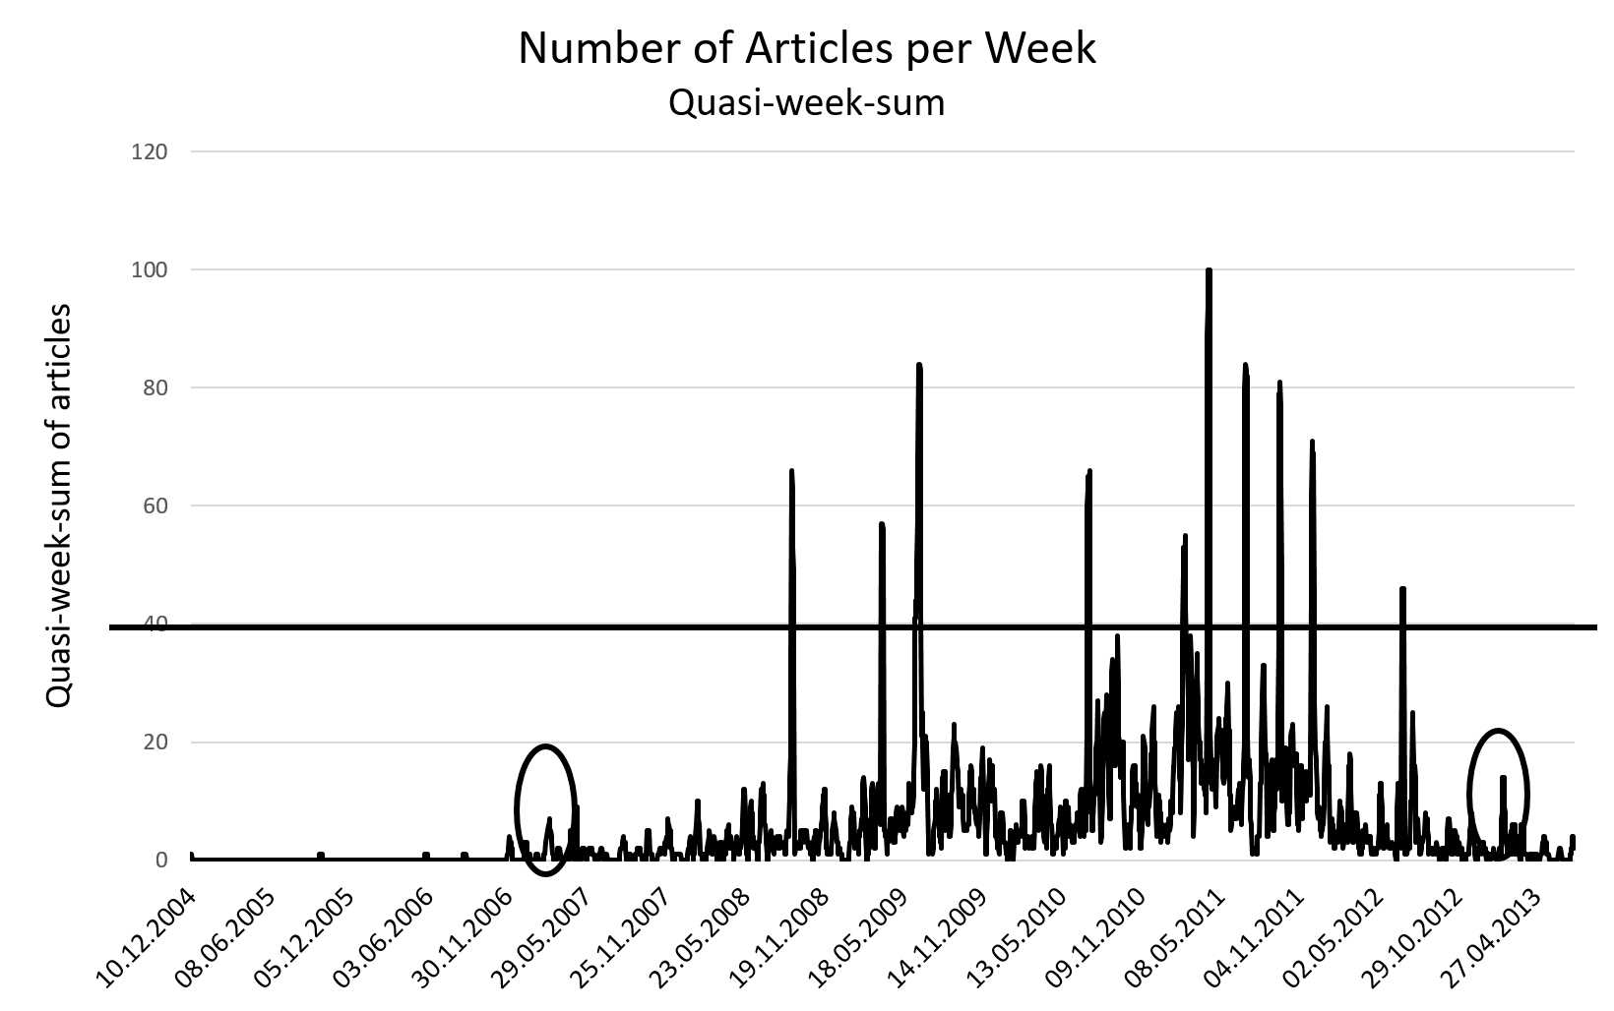

Figure 1: Quasi-week sum plotted per day. All articles for days with a quasi-week sum of forty or more (solid line), as well as all articles from May 2007 and February 2013 (solid circles), were included in the analysis.

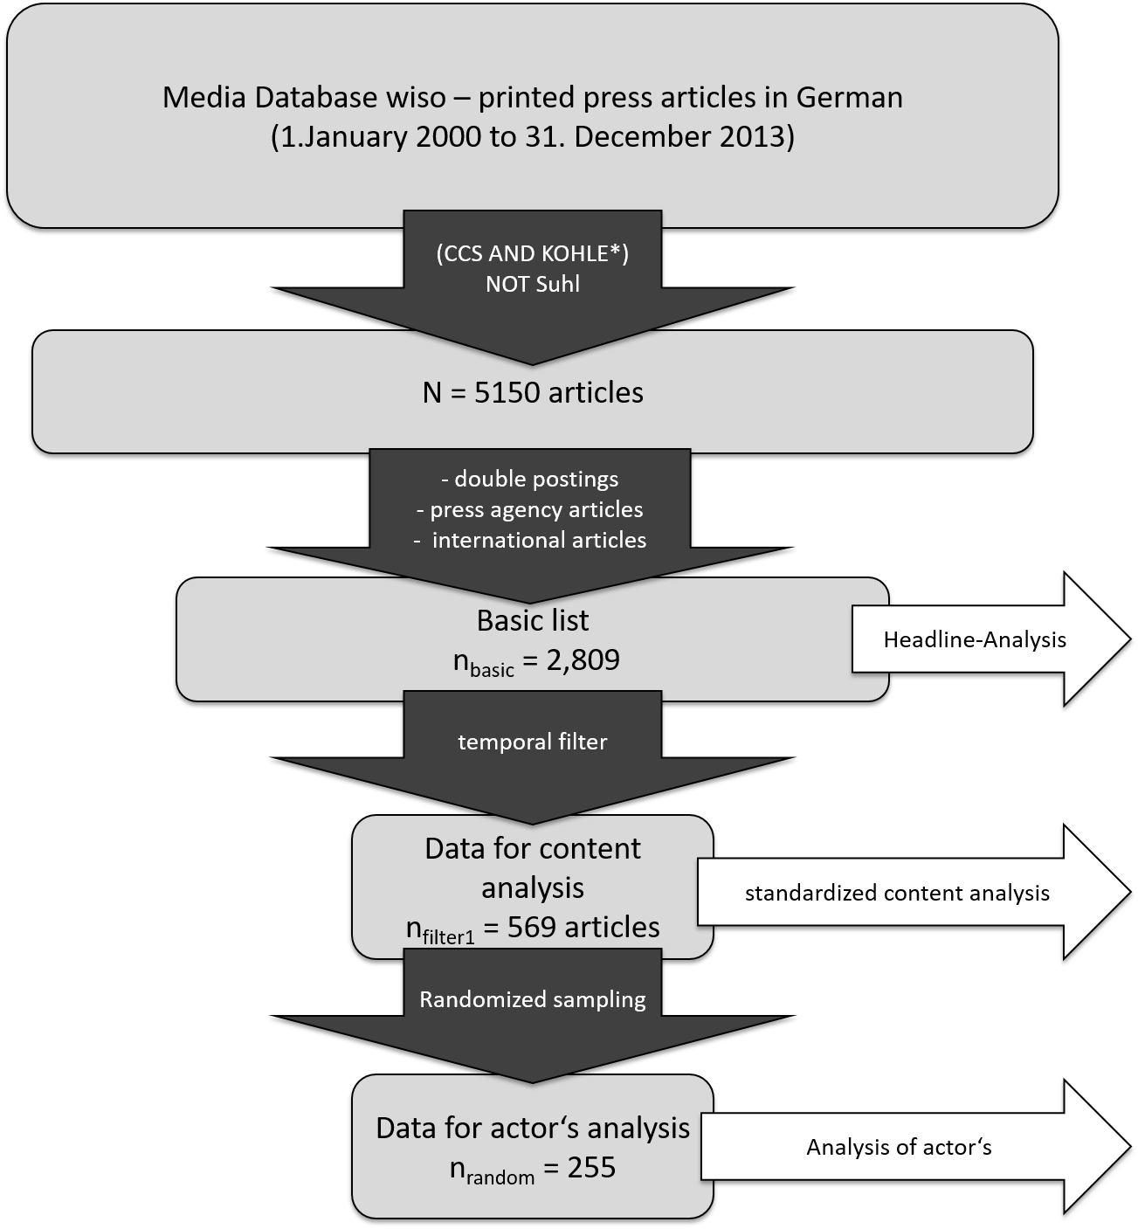
Figure 2: Sampling process: Within the first step, all articles collected in the media database (wiso) were scanned for keywords; within the second step, these articles were evaluated according to double postings, media agency releases, and international publications; for the third step, the resulting list was filtered according to a temporal filter; finally, a randomized sample was taken for a detailed actors’ analysis..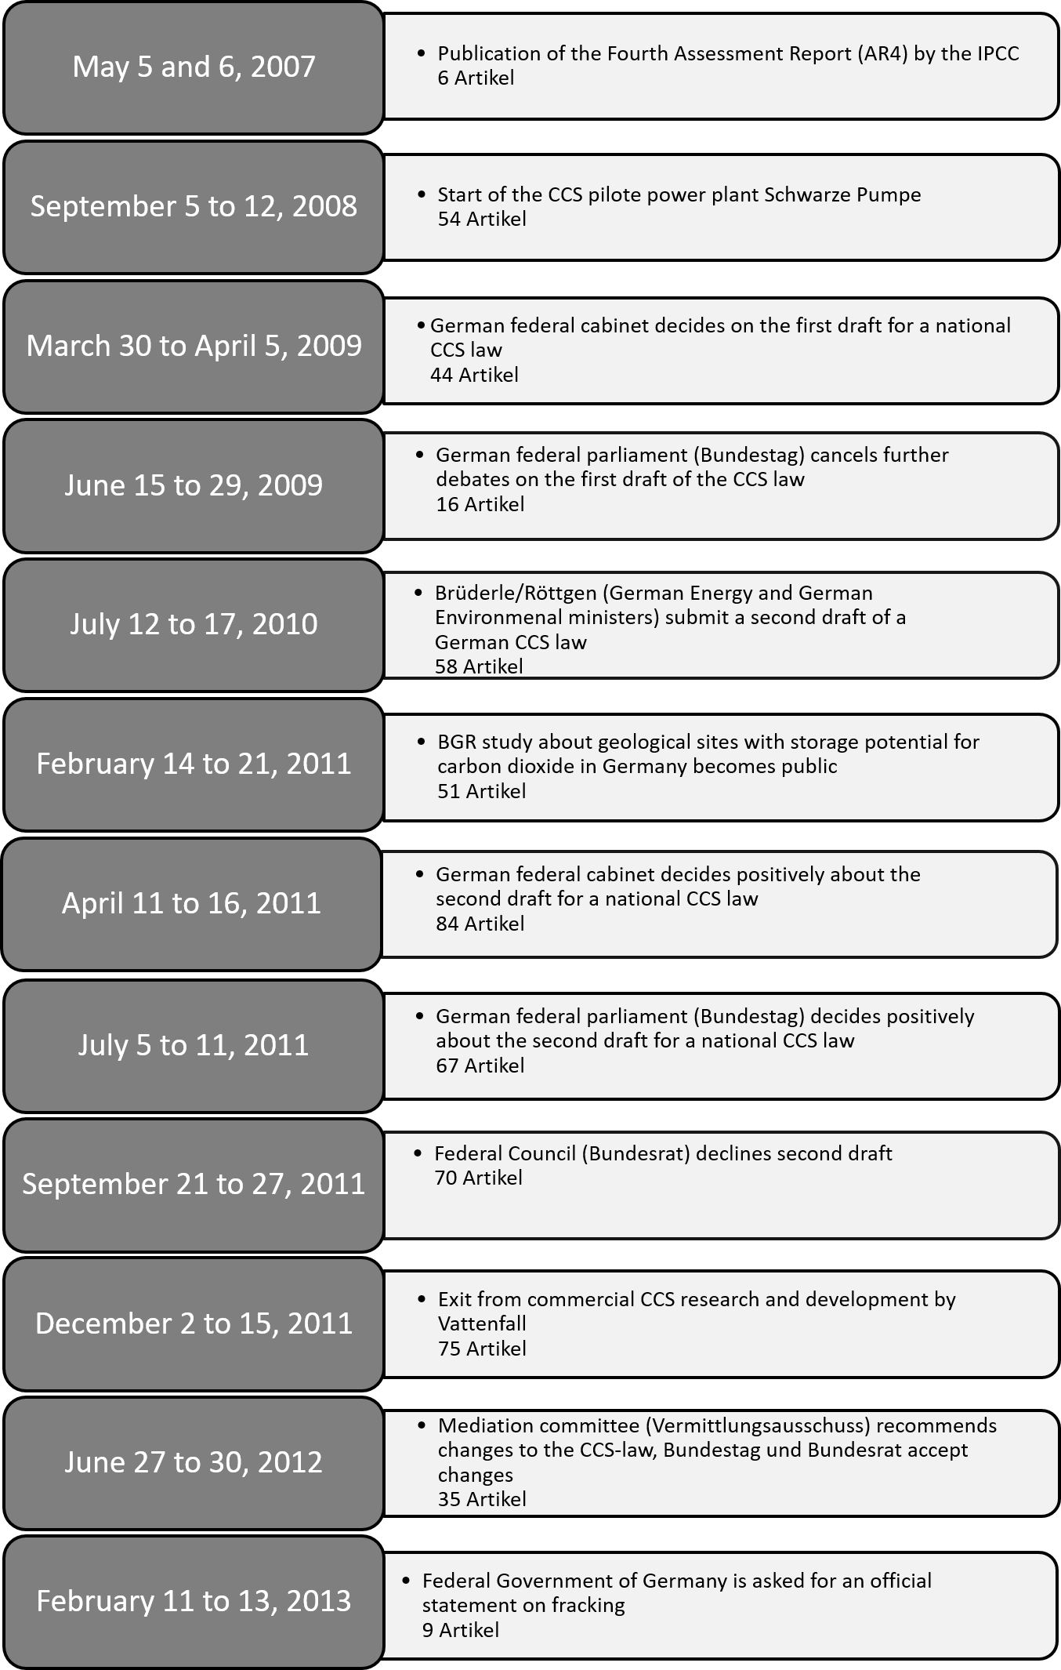
Table 1: Important dates for CCS research and development as well as CCS policy in Germany. The number of newspaper articles dealing with these events is given.

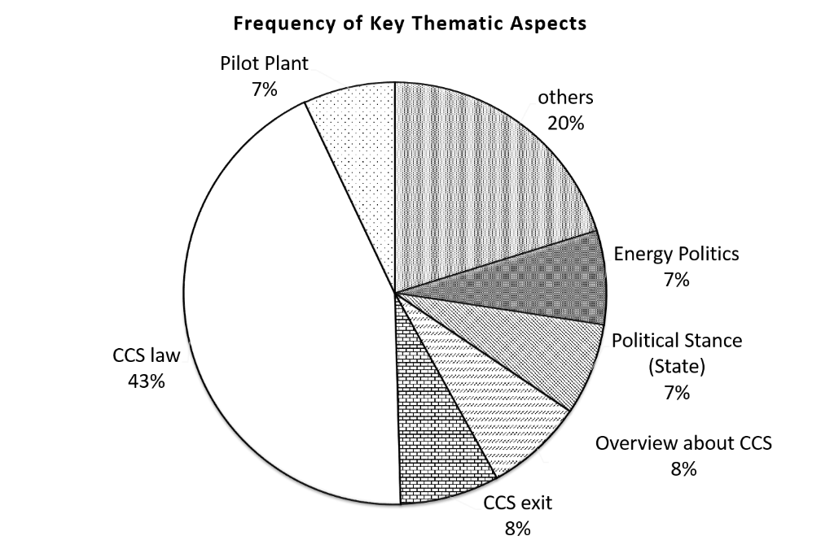
Figure 3: Distribution of the key thematic aspects (569 articles).

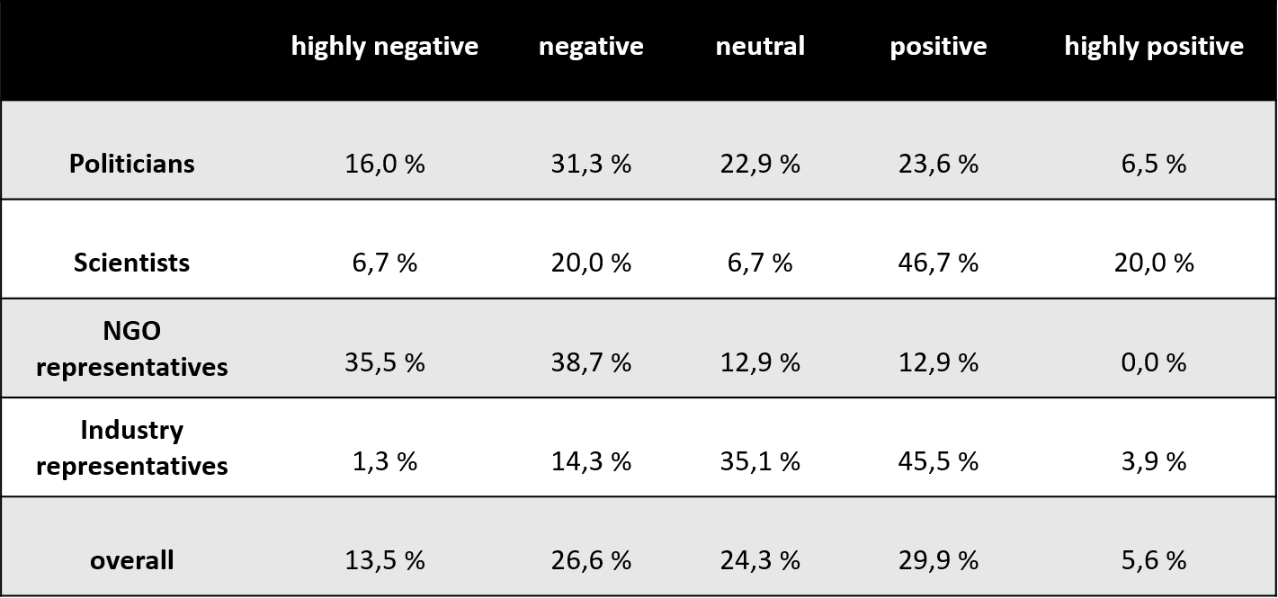
Table 2: Distribution of the trend in keyword use in relation to the four stakeholder groups (255 articles).

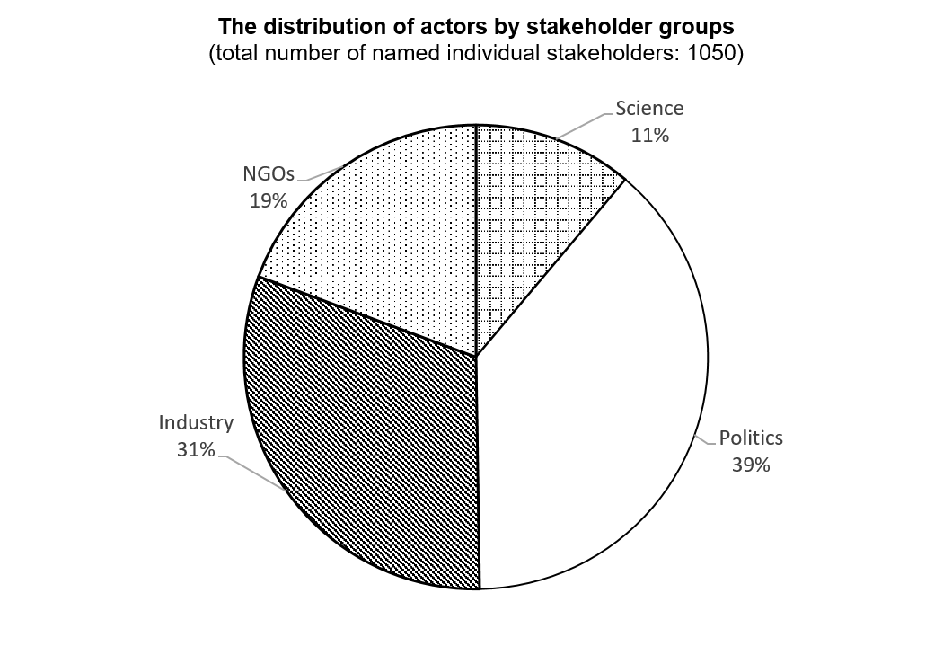
Figure 4: The distribution of actors by stakeholder groups as represented in German daily newspaper articles about CCS.

At the Freie Universität Berlin in Germany, the wiso Press database was used. This database included more than 120 million articles by German daily newspapers within the time frame of our analysis. More information about the database and the sources and titles that are included in it can be found on the GENIOS website (www.genios.de).
Because of the frequent use of CCS as an abbreviation for the Congress Centrum Suhl (Suhl Convention Center), a method to exclude Suhl was formulated within the search term: (CCS AND Kohle*) NOT Suhl.

